
Research Participants Wanted
UWA ethics approval number: 2022/ET000679

Quantifying thermal strain
during match-play badminton

Research Team
Contacts

A/Prof Olivier Girard
(UWA School of Human Sciences) olivier.girard@uwa.edu.au; phone +61 422 238 754

Dr Grant Landers
(UWA School of Human Sciences) 23428032@research.uwa.edu.au

Dr Ryan Lin
(Badminton Association of Western Australia ) r.lin@badmintonwa.org.au

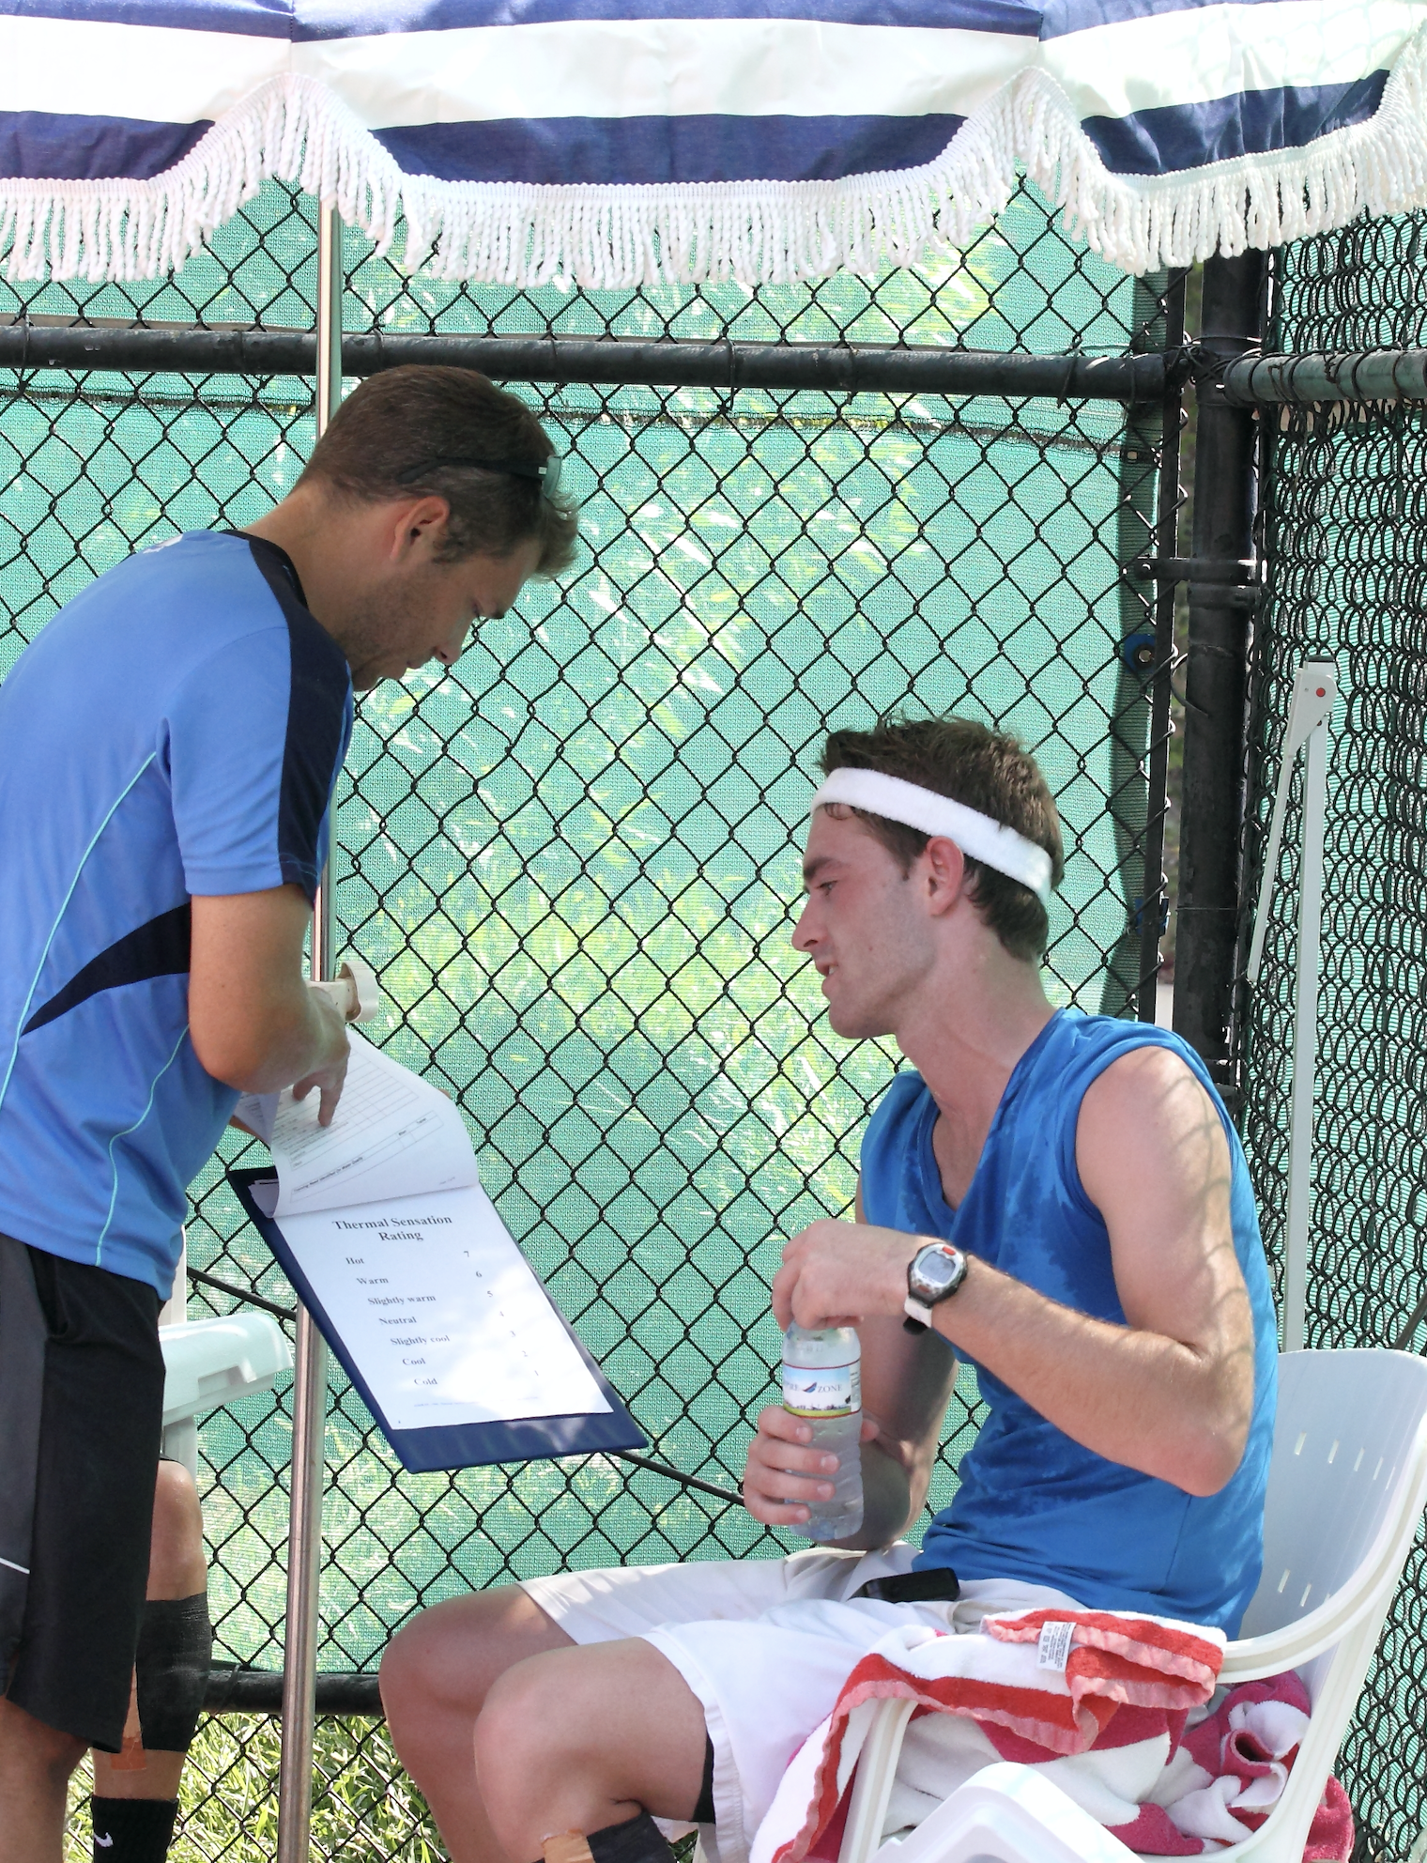

Are you a trained male or female badminton player (15-50 years old) who is curious about thermal strain experienced by badminton players with distinct training background (age, gender, performance level)?

You are invited to participate in a research study being conducted by researchers at the University of Western Australia.

This project aims to quantify the development of thermal, physiological and perceptual strain during badminton match-play in different players’ categories.

What does participation involve?
The completion of one single experimental session (~3 h in duration) including two consecutive simulated badminton games that will be scheduled at times that are convenient for you.

Following the study:
You will be able to receive a summary report detailing the general findings of the study as well as your own personal results including core temperature, hydration and sweat rate responses to badminton match play!

Why not volunteer to help us assess the acute thermal and psychophysiological responses associated with playing badminton?

Funding:
Badminton World Federation
(Sport Science Research Grants 2022/23)

